**Day 10 Assignment**

**10 Hypothesis That could Justify the attrition Patterns in the data.**

1. **Average PercentSalaryHike rate of attrition=Yes is >= 14**

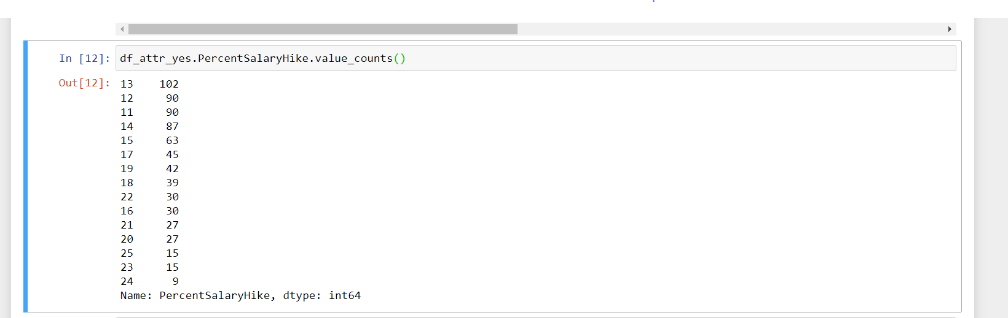

1. **Average Distance from home of attrition=Yes is <= 10**

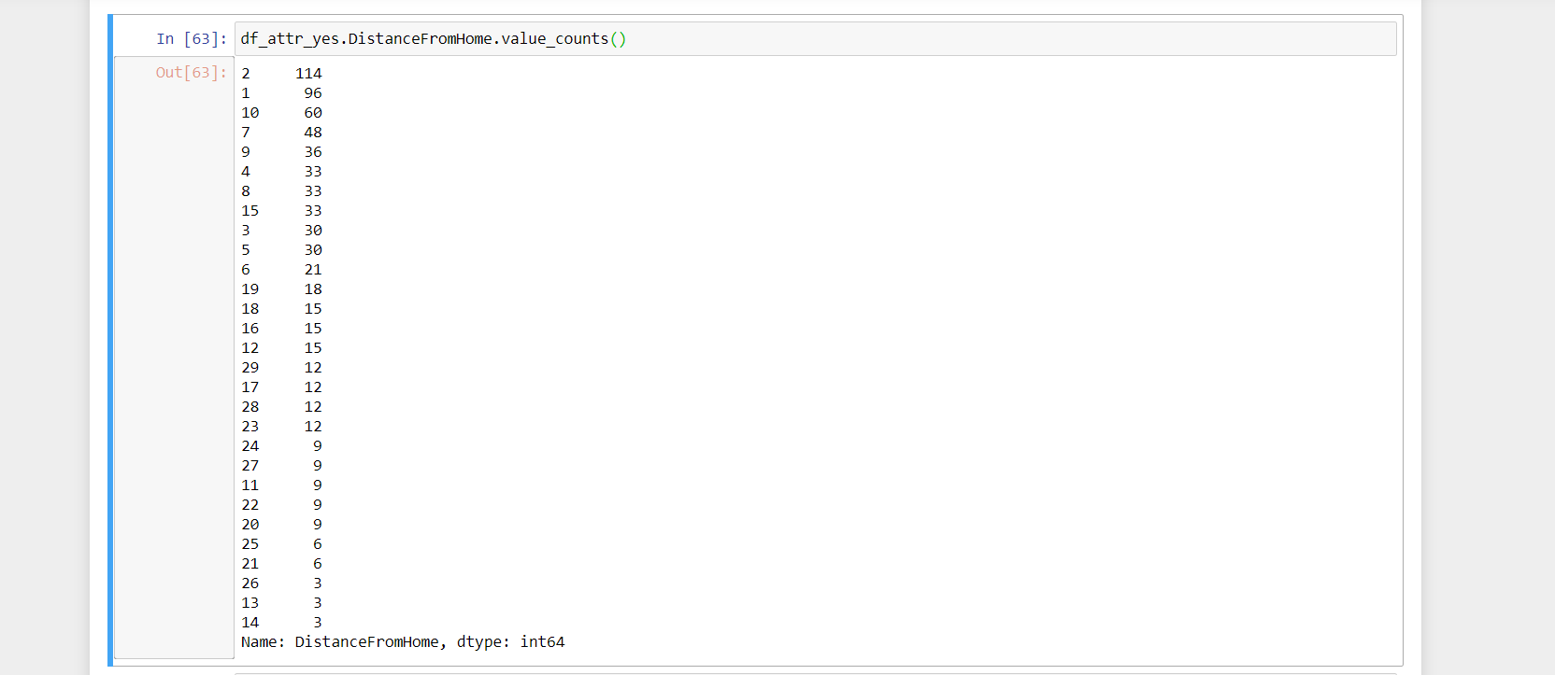

1. **Average Age of attrition=Yes is 33**



1. **The Divorced People are Mostly not Leaving**
2. **Single People Are leaving mostly**

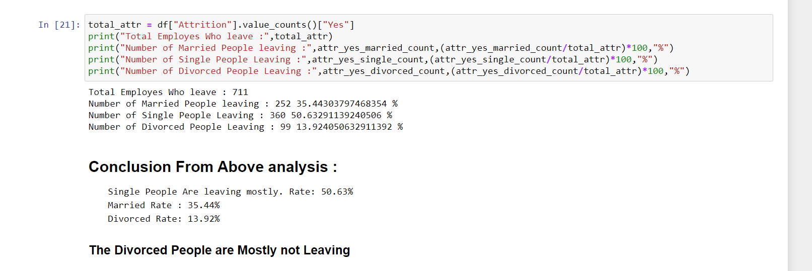

1. **Attrition rate of Female are more than male**

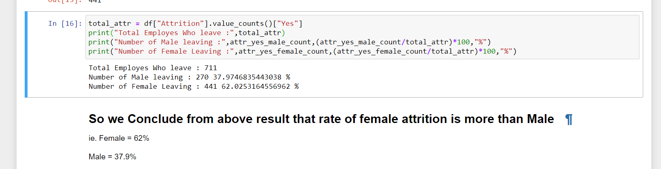

1. **People from Research and Development Department have a high Attrition Rate**



1. **The people who are at the company >=11 years have a low attrition Rate**

**Where as the people <11 Years have High Attrition Rate**

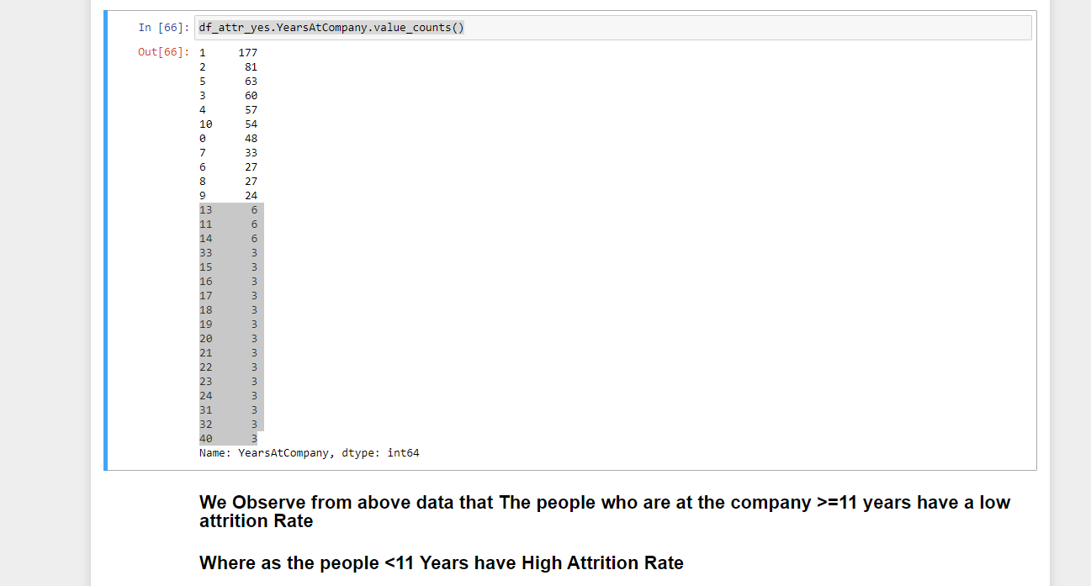

1. **Sales Executive, Research Scientist and Laboratory Technician have a high Attrition Rate As compared to other JobRole**

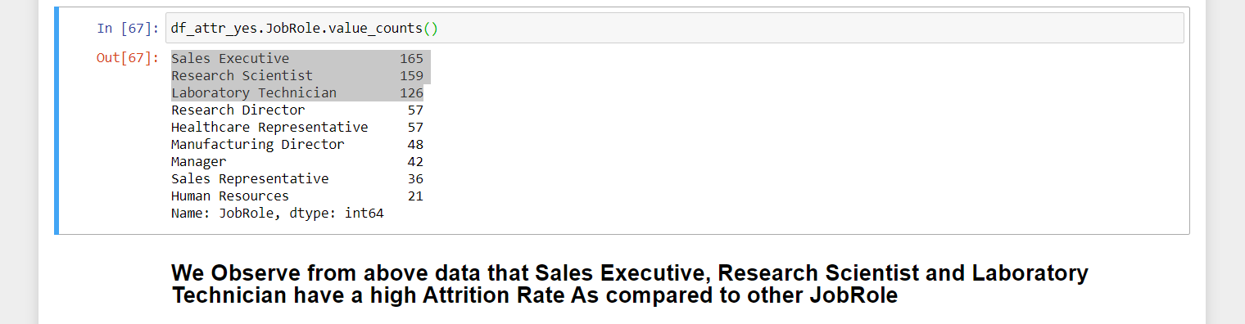

1. **Employees of Life Science and Medical Field have a high Attrition Rate**

